MTH 337
Report 5
The Butterfly Effect
by Tejas Vyas

Table of Contents
INTRODUCTION 3
ASSIGNMENT DETAILS 3
PROCEDURE 4
RESULTS and ANALYSIS 6
FURTHER IMPROVEMENTS 8
SOURCE CODE 9

INTRODUCTION
The Butterfly Effect is the sensitive dependence on initial conditions in which a small change in one state of a deterministic nonlinear system can result in large differences in a later state.
Coined by Edward Lorenz, the name of this effect is derived from the metaphorical example of the details of a hurricane being influenced by minor perturbations such as the flapping of the wings of a distant butterfly several weeks earlier.
Since most simple systems follow the effect, we will be using the Mayfly Model to test this hypothesis and figure out the possible difference in really close trajectories.

ASSIGNMENT DETAILS
In this assignment, using Python, we're trying to figure out if we can use the Mayfly Model to show the Butterfly effect in action for a given population x, time period t, and b. The equation of a trajectory of Mayfly population is given by
x_{t+1} = b (1−x_{t}) x_{t}
Our task is to find the separation s between the two population trajectories x1 and x2 and use it to map the possible situation. We will also be using one of the methods of regression analysis, Linear Least Squares to get a “best-fit” line for the given data by calculating α and β values for the given trajectories and plotting it accordingly.

PROCEDURE
This assignment is holds multiple steps to reach the desired output. We begin with creating the mayfly model trajectories and getting the separation between them. The function which does that may be implemented as:
function mayfly(input x,b,t){
x2 = x1 + 10⁻⁵ #Population for Trajectory 2
For all integers b in the range 1 < b < t:
x = b*(1-x)*x
x2 = b*(1-x2)*x2
return arrays containing x and x2 values #We will use this for Least Squares
}

Now, we move on to the actual part of the project. We calculate the separation between these trajectories and use the Linear Least Squares method to get a best fit for the solution.
The separation s is given by:
s = |x2(at t) – x1(at t)|
Now, we plot the function against time to get the separation value curve. This appears to be a decay differential equation, so to get a better curve we take log of s and use that to plot against time.
Now, we calculate the equation of the line for the best-fit. We're using the linear Least Squares method here an calculating the α and β values for the given trajectories x1 and x2 (denoted by x and y here).

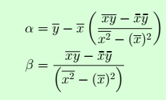
Finally, we plot the equation of the line and determine whether it appears to be the best fit for our model.
The function calculating all these may be written in pseudocode as:

function lls(x,b,t){
Assign x1,x2 from mayfly(x,b,t)
#Get the two arrays for Linear Least Square analysis from mayfly(x,b,t) and assign them as x1, x2.
Calculate α and β values using the formula above.
For the range(t):
plot the equation log(α + βt) w.r.t. t

To calculate mean for the α and β values, we're using the inbuilt numpy function mean and multiply (multiply multiplies two arrays). We're using semilogy to get our respective logarithmic plots.
Finally, we just the alpha and beta values to determine the growth rate of the differential equation presented to us by the mayfly model.

RESULTS and ANALYSIS

The test behaves differently for each combination of values of b and x. When we just look at the curve for the separation between trajectories, it appears close to a straight line, but still contains points not following the behavior. We have used the regression analysis method least linear squares in order to get a better sense of the curve and determine a more precise growth rate.
Here are our results for a couple test cases:
Case 1: x = 0.1, b = 4, t = 15
alpha = 0.0462356425349
beta = 0.936201962034
Resulting curve:
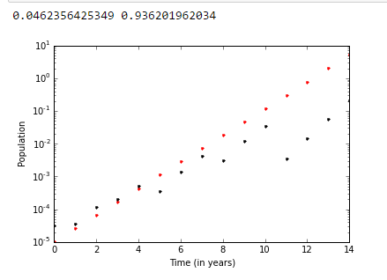
Case 2: x = 0.5, b = 3.9, t = 50
alpha = 0.210604731753
beta = 0.632189440598
Resulting curve:
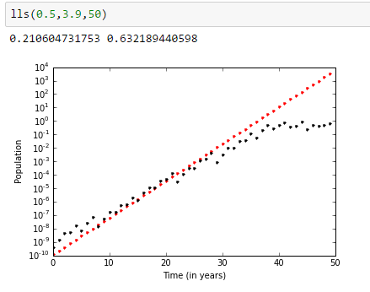
Determining the growth rate:
We clearly know that, s(t) = s(0)e^{rt}
=> log(s(t)) = log(s(0)) + rt = α + βt.
So, the growth rate r is just the value β found using linear least squares mentioned in the respective cases.

FURTHER IMPROVEMENTS
Our usage of linear least squares here is very basic. The efficiency of the algorithm drops significantly because of the matrix multiplication and multiple for loops inside the source. We can perform better and get a more accurate best-fit line by using the respective library functions which perform a much more efficient job at calculating the best-fit line.
Numpy holds one such function: using linalg.lstsq we should be able to retrace the best-fit more conveniently and accurately. Similar functions exist for scipy which use optimize method and a few more arguments to give a better regression analysis

SOURCE CODE

import math
from pylab import *
import numpy as np

def mayfly(x,b,t):
'''Calculate Mayfly Population trajectories for two initial populations differing but 1e-5'''
arrayx = []
x2 = x + 1e-5
arrayx2 = []
#s = abs(x2-x) #initializing s
#s0 = abs(x2-x) #Getting s at 0
for i in xrange(t):
#print x
#subplot(211) #I tried creating subplots for analysis but putting them on the same graph gave a better idea
#semilogy(i,s,'b.') #plot separation
x = b*(1-x)*x
arrayx.append(x)
x2 = b*(1-x2)*x2
arrayx2.append(x2)
#s = abs(x2-x) #updating s
#print "Final x is:"
#print mean(arrayx), mean(arrayx2)
#plot(arrayx,arrayx2, 'r.')
return arrayx, arrayx2

def lls(x,b,t):
'''Returns Least Linear Squares curve and respective growth rate'''
x1,x2 = mayfly(x,b,t)
#print x1,x2
beta = (mean(np.multiply(x1,x2)) - (mean(x1)*mean(x2)))/(mean(np.multiply(x1,x1)) - mean(x1)**2)
alpha = mean(x2) - (mean(x1)*beta)
y = x + 1e-5
for i in range(t):
#subplot(212)
semilogy(i, exp(alpha + (beta*i))/1e10,'r.')
semilogy(i, abs(x2[i]-x1[i]),'k.')
xlabel("Time (in years)")
ylabel("Population")
print alpha, beta

lls(0.5,3.9,50)
lls(0.1,4,15)

